VR Post-Experience Questionnaire
Dear Participant,
Thank you for taking part in this virtual reality (VR) walkthrough study. This survey collects your genuine feedback to refine VR scene design and user experience, and advance the integration of architectural design and human perception. Please read the instructions carefully:
Instructions
- This is a post-experience questionnaire, in which you will evaluate individual spatial nodes.
- The questionnaire consists of three sections. Section 1 includes 15 items measured on a 7-point Likert scale to support combined quantitative and qualitative analysis. Section 2 contains 8 items measured on a 5-point Likert scale, and Section 3 contains 9 items measured on a 5-point Likert scale.
- It will take approximately 5 minutes to complete the questionnaire. Thank you for your patience.
Your evaluations are critical to this research. We appreciate your careful responses.
Your name (only used for sample matching) [Text Entry] *

Part one. Spatial Node Evaluation
Please rate the target node across seven dimensions:
- Industrial atmosphere: Whether the node presents sufficient industrial elements and creates an industrial atmosphere.
- Spatial comfort: Whether the spatial scale, height-width ratio and ambient qualities induce discomfort.
- Architectural coherence: Whether the materiality and form of buildings match the atmosphere of this node.
- Landscape satisfaction: Your satisfaction with plants and water features at this node.
- Facility completeness: Adequacy of on-site amenities such as wayfinding and resting facilities.
- Functional adaptability: Whether the functions of this node fit its setting.
- Overall satisfaction: Overall satisfaction with this space.
1.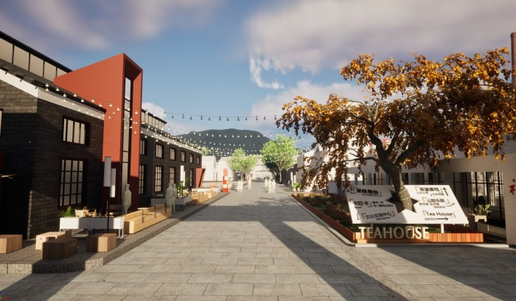
 | -3 | -2 | -1 | 0 | 1 | 2 | 3
Industrial atmosphere | ○ | ○ | ○ | ○ | ○ | ○ | ○
Spatial comfort | ○ | ○ | ○ | ○ | ○ | ○ | ○
Architectural coherence | ○ | ○ | ○ | ○ | ○ | ○ | ○
Landscape satisfaction | ○ | ○ | ○ | ○ | ○ | ○ | ○
Facility completeness | ○ | ○ | ○ | ○ | ○ | ○ | ○
Functional adaptability | ○ | ○ | ○ | ○ | ○ | ○ | ○
Overall satisfaction | ○ | ○ | ○ | ○ | ○ | ○ | ○

2.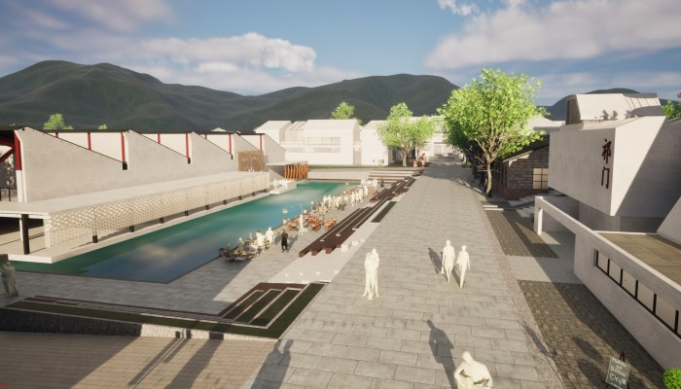
 | -3 | -2 | -1 | 0 | 1 | 2 | 3
Industrial atmosphere | ○ | ○ | ○ | ○ | ○ | ○ | ○
Spatial comfort | ○ | ○ | ○ | ○ | ○ | ○ | ○
Architectural coherence | ○ | ○ | ○ | ○ | ○ | ○ | ○
Landscape satisfaction | ○ | ○ | ○ | ○ | ○ | ○ | ○
Facility completeness | ○ | ○ | ○ | ○ | ○ | ○ | ○
Functional adaptability | ○ | ○ | ○ | ○ | ○ | ○ | ○
Overall satisfaction | ○ | ○ | ○ | ○ | ○ | ○ | ○

3.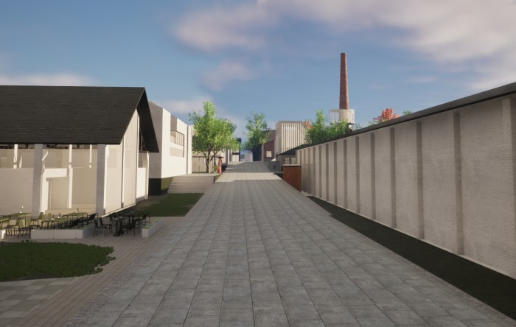
 | -3 | -2 | -1 | 0 | 1 | 2 | 3
Industrial atmosphere | ○ | ○ | ○ | ○ | ○ | ○ | ○
Spatial comfort | ○ | ○ | ○ | ○ | ○ | ○ | ○
Architectural coherence | ○ | ○ | ○ | ○ | ○ | ○ | ○
Landscape satisfaction | ○ | ○ | ○ | ○ | ○ | ○ | ○
Facility completeness | ○ | ○ | ○ | ○ | ○ | ○ | ○
Functional adaptability | ○ | ○ | ○ | ○ | ○ | ○ | ○
Overall satisfaction | ○ | ○ | ○ | ○ | ○ | ○ | ○

4.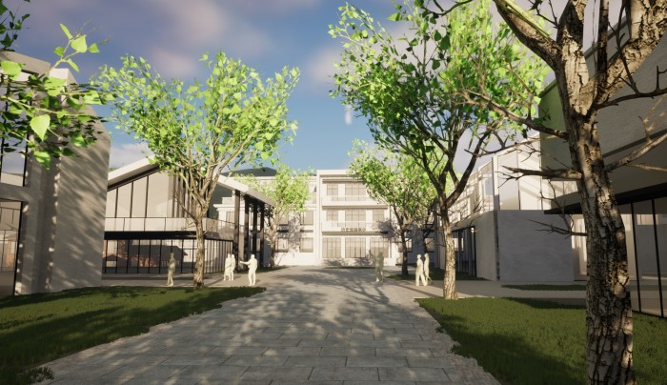
 | -3 | -2 | -1 | 0 | 1 | 2 | 3
Industrial atmosphere | ○ | ○ | ○ | ○ | ○ | ○ | ○
Spatial comfort | ○ | ○ | ○ | ○ | ○ | ○ | ○
Architectural coherence | ○ | ○ | ○ | ○ | ○ | ○ | ○
Landscape satisfaction | ○ | ○ | ○ | ○ | ○ | ○ | ○
Facility completeness | ○ | ○ | ○ | ○ | ○ | ○ | ○
Functional adaptability | ○ | ○ | ○ | ○ | ○ | ○ | ○
Overall satisfaction | ○ | ○ | ○ | ○ | ○ | ○ | ○

5.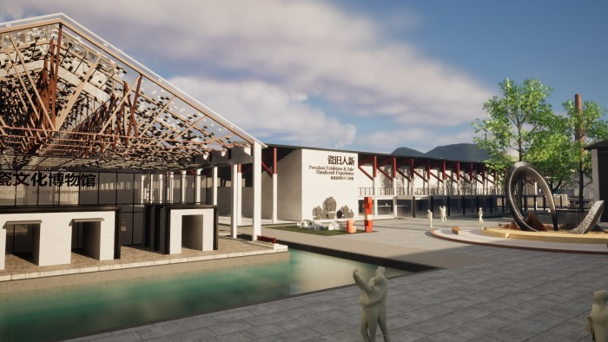
 | -3 | -2 | -1 | 0 | 1 | 2 | 3
Industrial atmosphere | ○ | ○ | ○ | ○ | ○ | ○ | ○
Spatial comfort | ○ | ○ | ○ | ○ | ○ | ○ | ○
Architectural coherence | ○ | ○ | ○ | ○ | ○ | ○ | ○
Landscape satisfaction | ○ | ○ | ○ | ○ | ○ | ○ | ○
Facility completeness | ○ | ○ | ○ | ○ | ○ | ○ | ○
Functional adaptability | ○ | ○ | ○ | ○ | ○ | ○ | ○
Overall satisfaction | ○ | ○ | ○ | ○ | ○ | ○ | ○

6.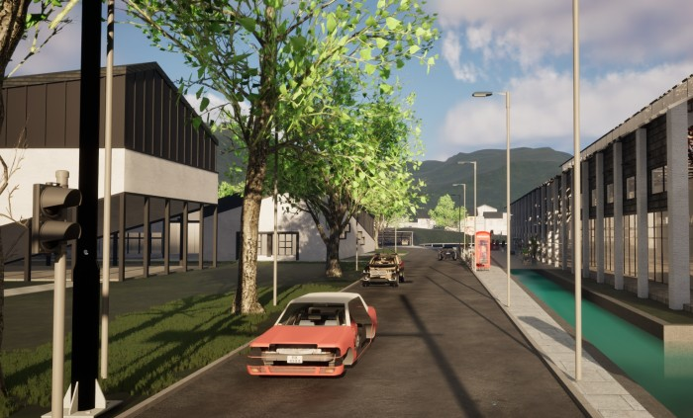
 | -3 | -2 | -1 | 0 | 1 | 2 | 3
Industrial atmosphere | ○ | ○ | ○ | ○ | ○ | ○ | ○
Spatial comfort | ○ | ○ | ○ | ○ | ○ | ○ | ○
Architectural coherence | ○ | ○ | ○ | ○ | ○ | ○ | ○
Landscape satisfaction | ○ | ○ | ○ | ○ | ○ | ○ | ○
Facility completeness | ○ | ○ | ○ | ○ | ○ | ○ | ○
Functional adaptability | ○ | ○ | ○ | ○ | ○ | ○ | ○
Overall satisfaction | ○ | ○ | ○ | ○ | ○ | ○ | ○

7.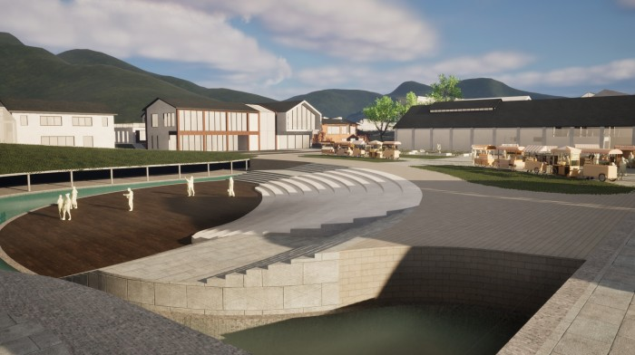
 | -3 | -2 | -1 | 0 | 1 | 2 | 3
Industrial atmosphere | ○ | ○ | ○ | ○ | ○ | ○ | ○
Spatial comfort | ○ | ○ | ○ | ○ | ○ | ○ | ○
Architectural coherence | ○ | ○ | ○ | ○ | ○ | ○ | ○
Landscape satisfaction | ○ | ○ | ○ | ○ | ○ | ○ | ○
Facility completeness | ○ | ○ | ○ | ○ | ○ | ○ | ○
Functional adaptability | ○ | ○ | ○ | ○ | ○ | ○ | ○
Overall satisfaction | ○ | ○ | ○ | ○ | ○ | ○ | ○

8.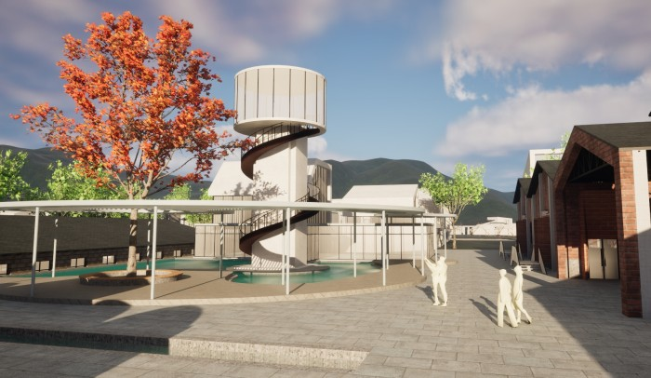
 | -3 | -2 | -1 | 0 | 1 | 2 | 3
Industrial atmosphere | ○ | ○ | ○ | ○ | ○ | ○ | ○
Spatial comfort | ○ | ○ | ○ | ○ | ○ | ○ | ○
Architectural coherence | ○ | ○ | ○ | ○ | ○ | ○ | ○
Landscape satisfaction | ○ | ○ | ○ | ○ | ○ | ○ | ○
Facility completeness | ○ | ○ | ○ | ○ | ○ | ○ | ○
Functional adaptability | ○ | ○ | ○ | ○ | ○ | ○ | ○
Overall satisfaction | ○ | ○ | ○ | ○ | ○ | ○ | ○

9.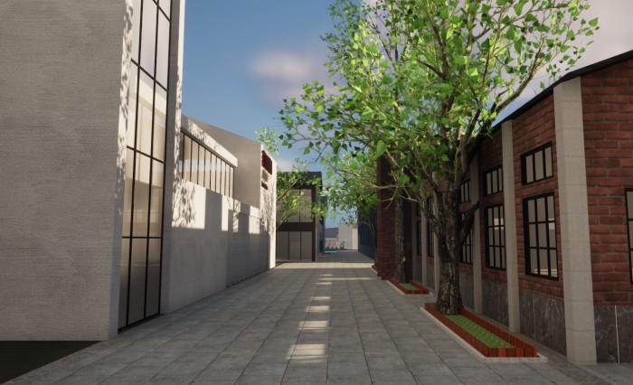
 | -3 | -2 | -1 | 0 | 1 | 2 | 3
Industrial atmosphere | ○ | ○ | ○ | ○ | ○ | ○ | ○
Spatial comfort | ○ | ○ | ○ | ○ | ○ | ○ | ○
Architectural coherence | ○ | ○ | ○ | ○ | ○ | ○ | ○
Landscape satisfaction | ○ | ○ | ○ | ○ | ○ | ○ | ○
Facility completeness | ○ | ○ | ○ | ○ | ○ | ○ | ○
Functional adaptability | ○ | ○ | ○ | ○ | ○ | ○ | ○
Overall satisfaction | ○ | ○ | ○ | ○ | ○ | ○ | ○

10.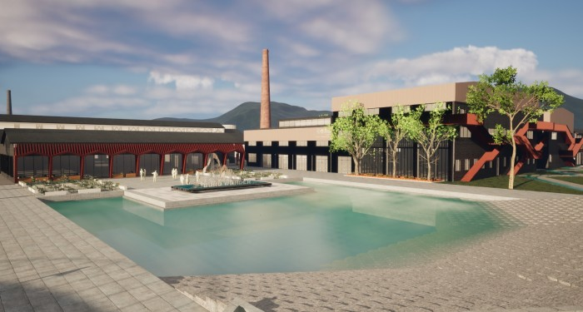
 | -3 | -2 | -1 | 0 | 1 | 2 | 3
Industrial atmosphere | ○ | ○ | ○ | ○ | ○ | ○ | ○
Spatial comfort | ○ | ○ | ○ | ○ | ○ | ○ | ○
Architectural coherence | ○ | ○ | ○ | ○ | ○ | ○ | ○
Landscape satisfaction | ○ | ○ | ○ | ○ | ○ | ○ | ○
Facility completeness | ○ | ○ | ○ | ○ | ○ | ○ | ○
Functional adaptability | ○ | ○ | ○ | ○ | ○ | ○ | ○
Overall satisfaction | ○ | ○ | ○ | ○ | ○ | ○ | ○

11.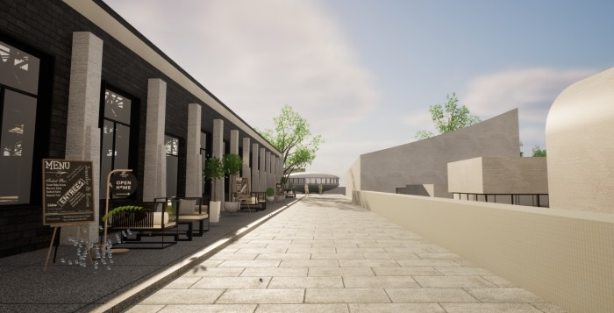
 | -3 | -2 | -1 | 0 | 1 | 2 | 3
Industrial atmosphere | ○ | ○ | ○ | ○ | ○ | ○ | ○
Spatial comfort | ○ | ○ | ○ | ○ | ○ | ○ | ○
Architectural coherence | ○ | ○ | ○ | ○ | ○ | ○ | ○
Landscape satisfaction | ○ | ○ | ○ | ○ | ○ | ○ | ○
Facility completeness | ○ | ○ | ○ | ○ | ○ | ○ | ○
Functional adaptability | ○ | ○ | ○ | ○ | ○ | ○ | ○
Overall satisfaction | ○ | ○ | ○ | ○ | ○ | ○ | ○

12.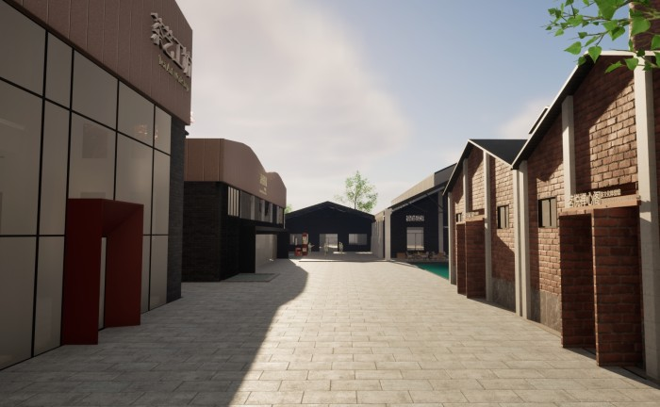
 | -3 | -2 | -1 | 0 | 1 | 2 | 3
Industrial atmosphere | ○ | ○ | ○ | ○ | ○ | ○ | ○
Spatial comfort | ○ | ○ | ○ | ○ | ○ | ○ | ○
Architectural coherence | ○ | ○ | ○ | ○ | ○ | ○ | ○
Landscape satisfaction | ○ | ○ | ○ | ○ | ○ | ○ | ○
Facility completeness | ○ | ○ | ○ | ○ | ○ | ○ | ○
Functional adaptability | ○ | ○ | ○ | ○ | ○ | ○ | ○
Overall satisfaction | ○ | ○ | ○ | ○ | ○ | ○ | ○

13.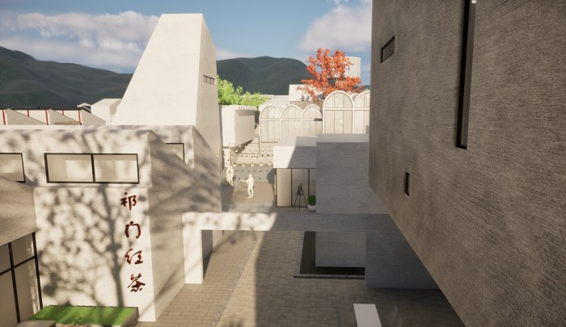
 | -3 | -2 | -1 | 0 | 1 | 2 | 3
Industrial atmosphere | ○ | ○ | ○ | ○ | ○ | ○ | ○
Spatial comfort | ○ | ○ | ○ | ○ | ○ | ○ | ○
Architectural coherence | ○ | ○ | ○ | ○ | ○ | ○ | ○
Landscape satisfaction | ○ | ○ | ○ | ○ | ○ | ○ | ○
Facility completeness | ○ | ○ | ○ | ○ | ○ | ○ | ○
Functional adaptability | ○ | ○ | ○ | ○ | ○ | ○ | ○
Overall satisfaction | ○ | ○ | ○ | ○ | ○ | ○ | ○

14.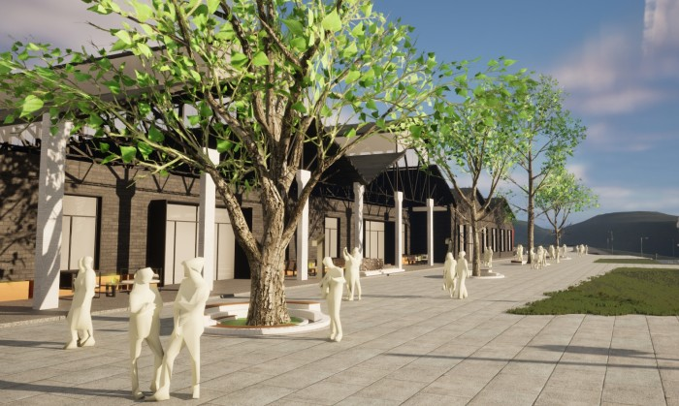
 | -3 | -2 | -1 | 0 | 1 | 2 | 3
Industrial atmosphere | ○ | ○ | ○ | ○ | ○ | ○ | ○
Spatial comfort | ○ | ○ | ○ | ○ | ○ | ○ | ○
Architectural coherence | ○ | ○ | ○ | ○ | ○ | ○ | ○
Landscape satisfaction | ○ | ○ | ○ | ○ | ○ | ○ | ○
Facility completeness | ○ | ○ | ○ | ○ | ○ | ○ | ○
Functional adaptability | ○ | ○ | ○ | ○ | ○ | ○ | ○
Overall satisfaction | ○ | ○ | ○ | ○ | ○ | ○ | ○

15.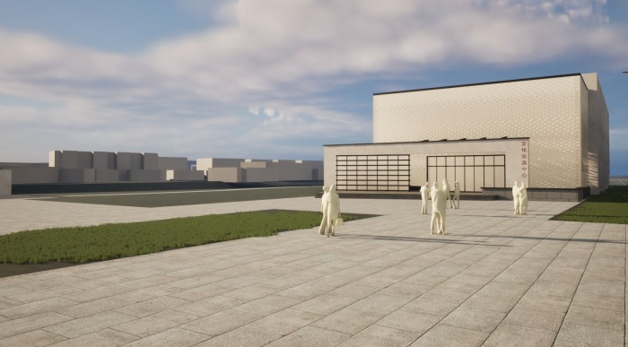
 | -3 | -2 | -1 | 0 | 1 | 2 | 3
Industrial atmosphere | ○ | ○ | ○ | ○ | ○ | ○ | ○
Spatial comfort | ○ | ○ | ○ | ○ | ○ | ○ | ○
Architectural coherence | ○ | ○ | ○ | ○ | ○ | ○ | ○
Landscape satisfaction | ○ | ○ | ○ | ○ | ○ | ○ | ○
Facility completeness | ○ | ○ | ○ | ○ | ○ | ○ | ○
Functional adaptability | ○ | ○ | ○ | ○ | ○ | ○ | ○
Overall satisfaction | ○ | ○ | ○ | ○ | ○ | ○ | ○

Factor | Question | totally agree | agree | neutral | disagree | totally disagree
Graphical satisfaction (GP)* | I appreciate the visual graphics of the virtual model. | ○ | ○ | ○ | ○ | ○
Spatial presence (SP)* | I perceive this space as a place I am visiting, rather than a photograph I am viewing. | ○ | ○ | ○ | ○ | ○
Spatial presence (SP)* | I felt a sense of presence during the experience. | ○ | ○ | ○ | ○ | ○
Spatial presence (SP)* | I perceive the virtual model as immersive. | ○ | ○ | ○ | ○ | ○
Involvement (INV) | During the experience, I was not aware of the real world surrounding me. | ○ | ○ | ○ | ○ | ○
Experienced realism (REAL)* | I perceive that objects within the virtual world are scaled correctly. | ○ | ○ | ○ | ○ | ○
Experienced realism (REAL)* | I feel capable of interacting with the virtual space. | ○ | ○ | ○ | ○ | ○
Experienced realism (REAL)* | I find the virtual model realistic. | ○ | ○ | ○ | ○ | ○
Part two. Perceptual Experience during VR Exploration

Part three. Physical and Sensory Responses During and After VR Exposure

Factor | Barely | A little bit | Slightly | Mildly | A lot
General discomfort | ○ | ○ | ○ | ○ | ○
Fatigue | ○ | ○ | ○ | ○ | ○
Eyestrain | ○ | ○ | ○ | ○ | ○
Difficulty focusing | ○ | ○ | ○ | ○ | ○
Headache | ○ | ○ | ○ | ○ | ○
Fullness of head | ○ | ○ | ○ | ○ | ○
Blurred vision | ○ | ○ | ○ | ○ | ○
Dizzy (eyes closed) | ○ | ○ | ○ | ○ | ○
Vertigo | ○ | ○ | ○ | ○ | ○

